NAME: P.Deepak
ROLL.NO:2303a52179
BATCH:42
ASSIGNMEN 4.4
TASK-1
ZERO SHOT PROMPT: generate a code that analyxe customer review on an ecommerce website and classify them as positive, negative or neutral sentment create 10 reviews inside the code itself and print the classification result for each review.
Code:
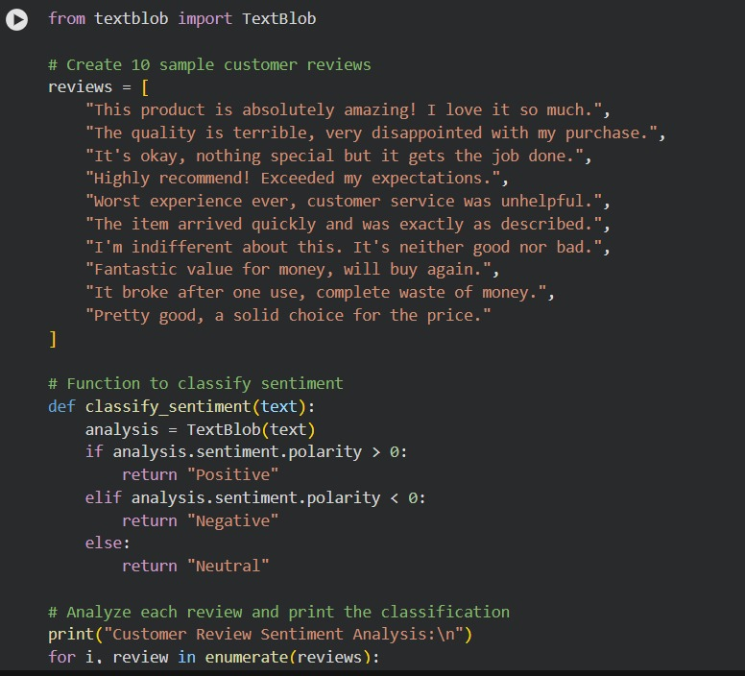

Output:
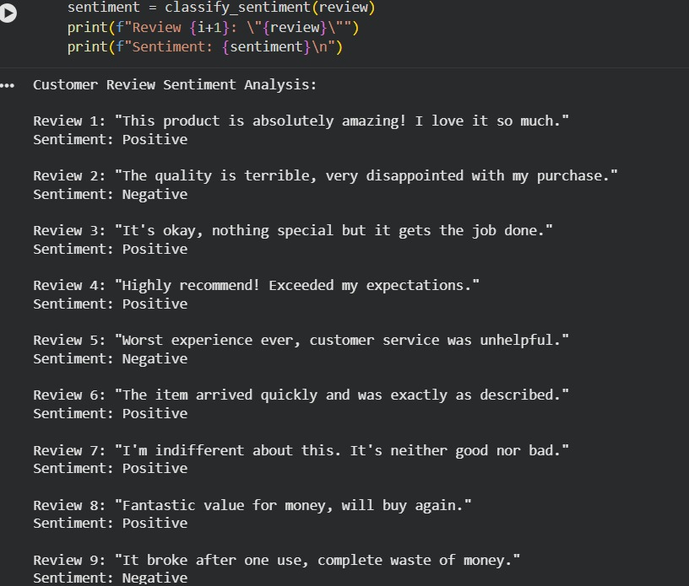
ONE- SHOT: classify the reviews mapped to sentiments
Review: I absolutely love this product! It has changed my life for the better.
Sentiment: Positive.
now generate python code to display the output for all reviews in the same format as above.i want
data in code itself not in output.

Code:
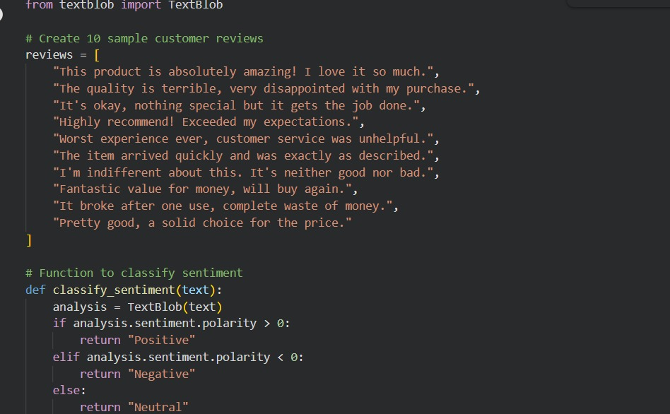
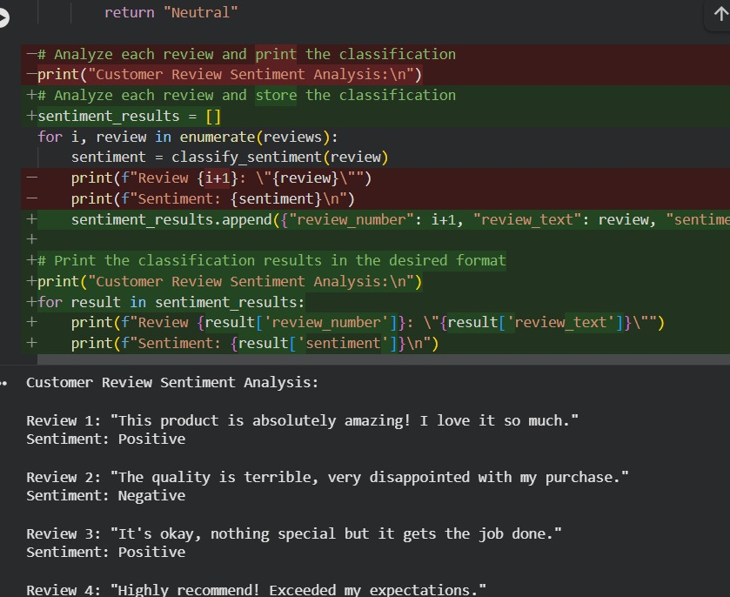
Output:
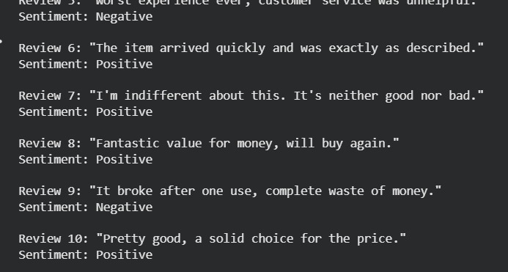
TASK2:
ONE SHOT PROMPT: Prioritzing the incoming emails. Example: The production server is not responding. fix ASAP . Priority: High. Now generate python code to classify email priority into high, medium and low based on certain keywords. Create 10 email samples inside the code itself and print the classification result for each email.
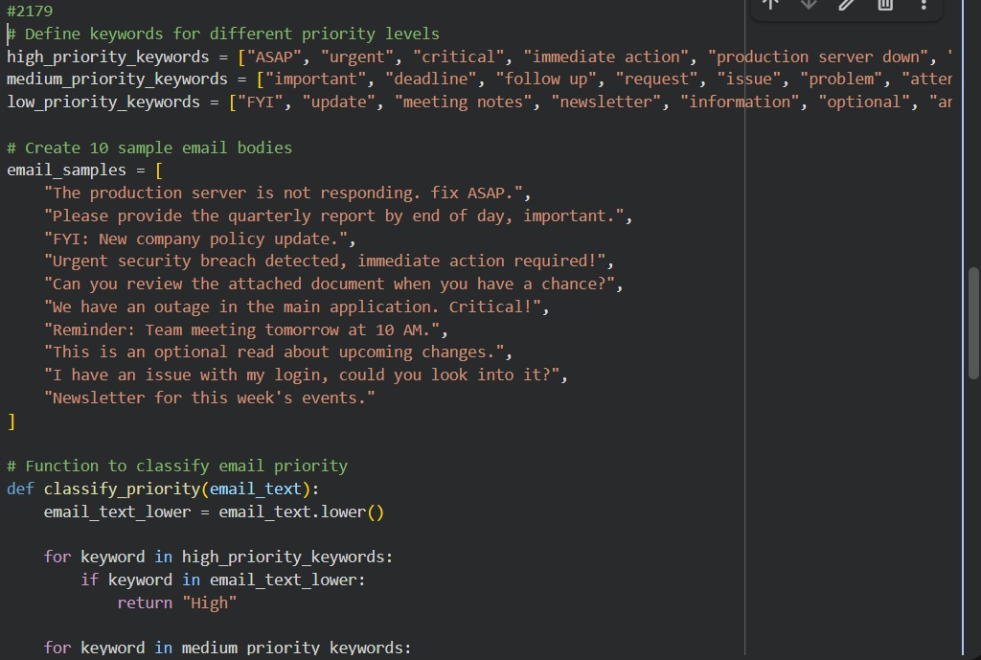
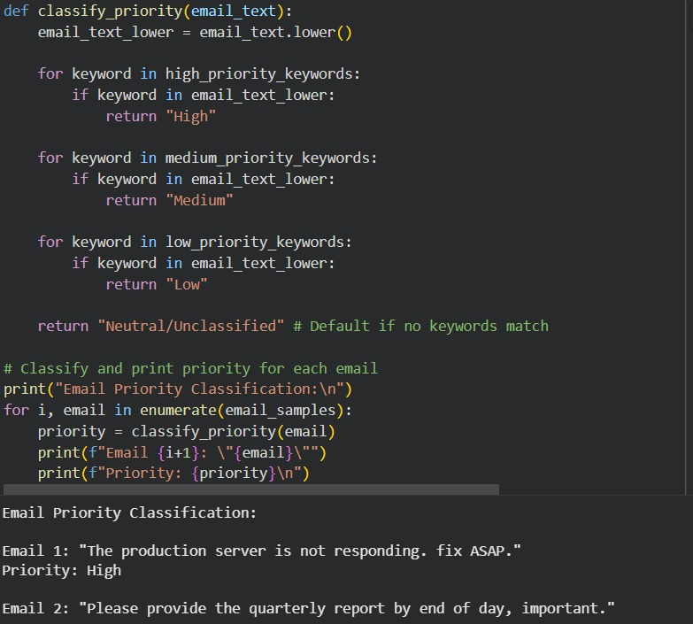
Output:
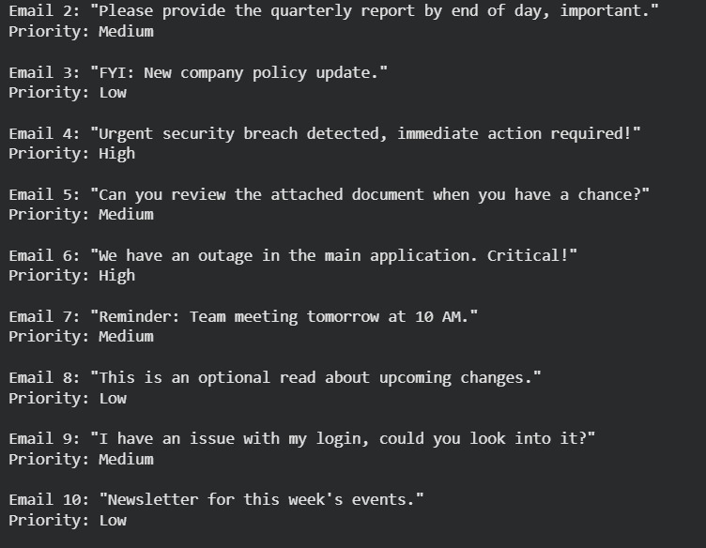
FEW SHOT PROMPT:
Classify the emails mapped to priorities .Email: The production server is not responding. Fix ASAP. Priority: High. email: Reminder: Team meeting scheduled for tomorrow.Priority: Medium. Now generate python code to display the output for all emails in the same format as above.i want data in code itself not in output.
CODE:
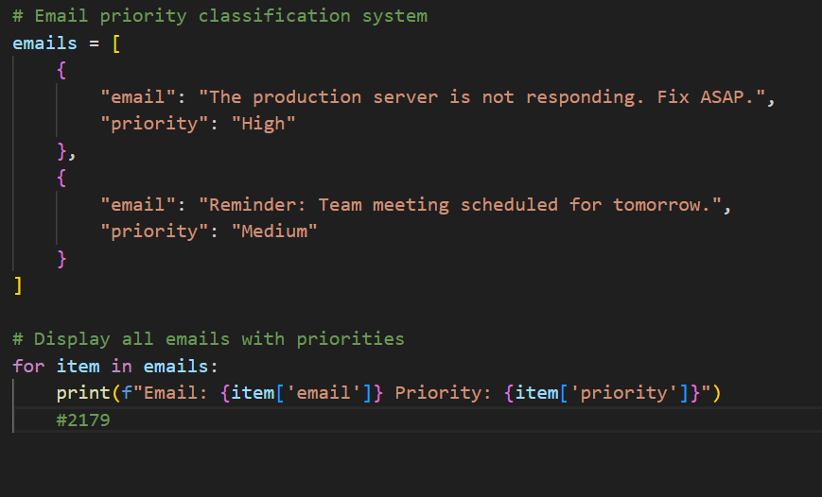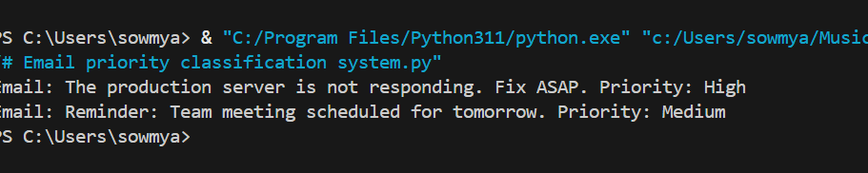
TASK3:
ZERO SHOT PROMPT: Write a python code for classiying the student queries to admissions, exams, fees and others based on certain keywords. Create 10 student queries inside the code itself and print the classification result for each query.
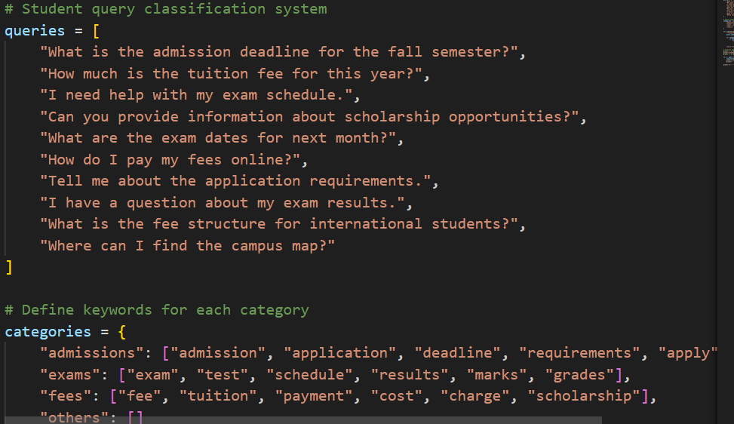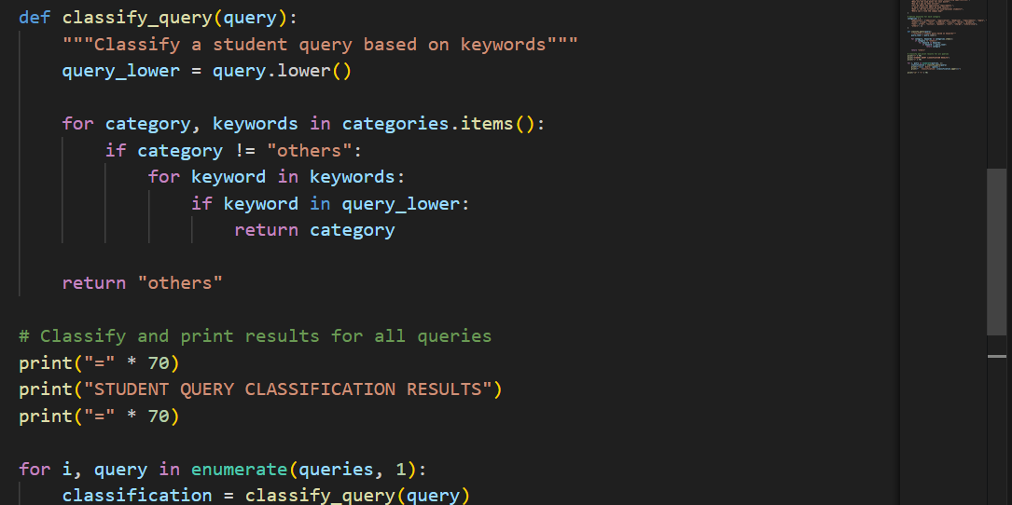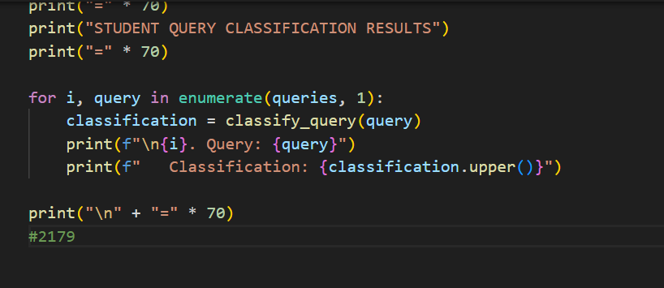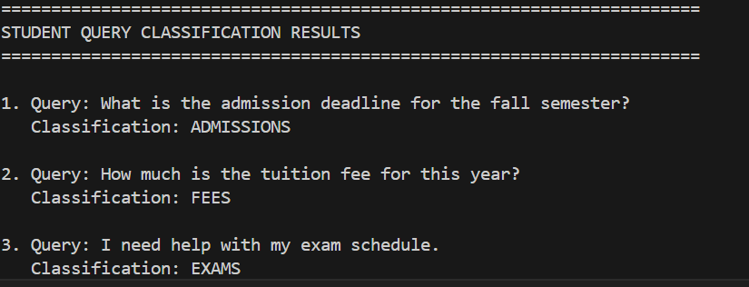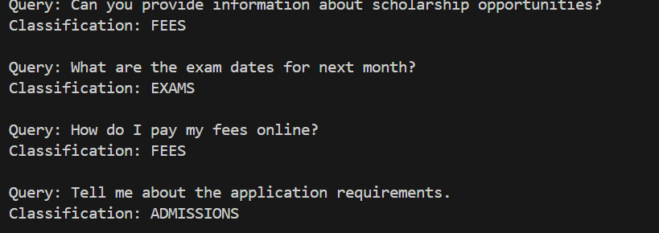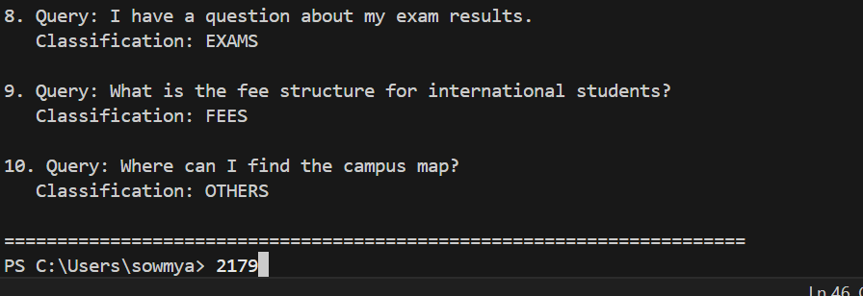
Task-3
ONE SHOT:
Write a python code for classiying the student queries to admissions, exams, fees and others based
on certain keywords.create 10 student queries inside the code itself and print the classification reult
for each query.Example: I apply for admission to the university?,When are the final exams scheduled
for this semester?Now generate python code to display the output for all queries in the same format
as above.i want data in code itself not in output.
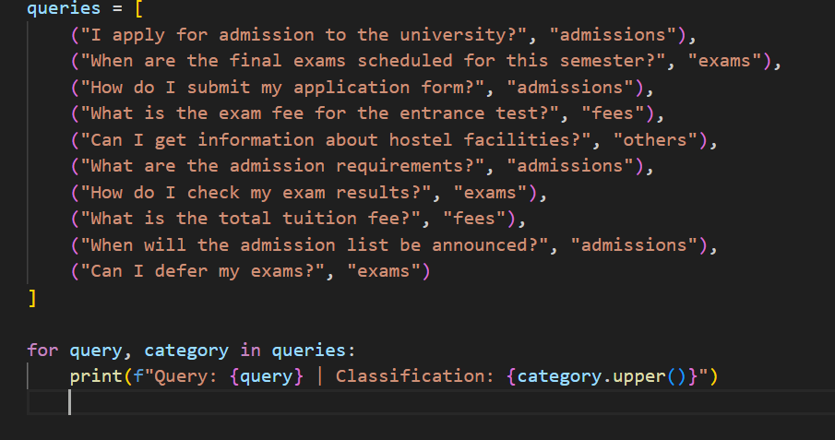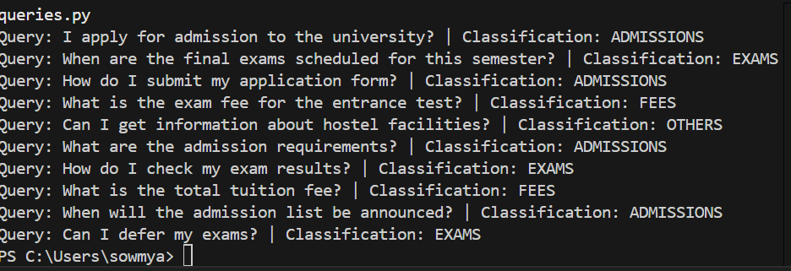
TASK4: ZERO SHOT: Generate the Python code that identifies whether a user query is Informational, Transactional, Complaint, or Feedback. Create 10 user queries inside the code itself and print the classification result for each query.
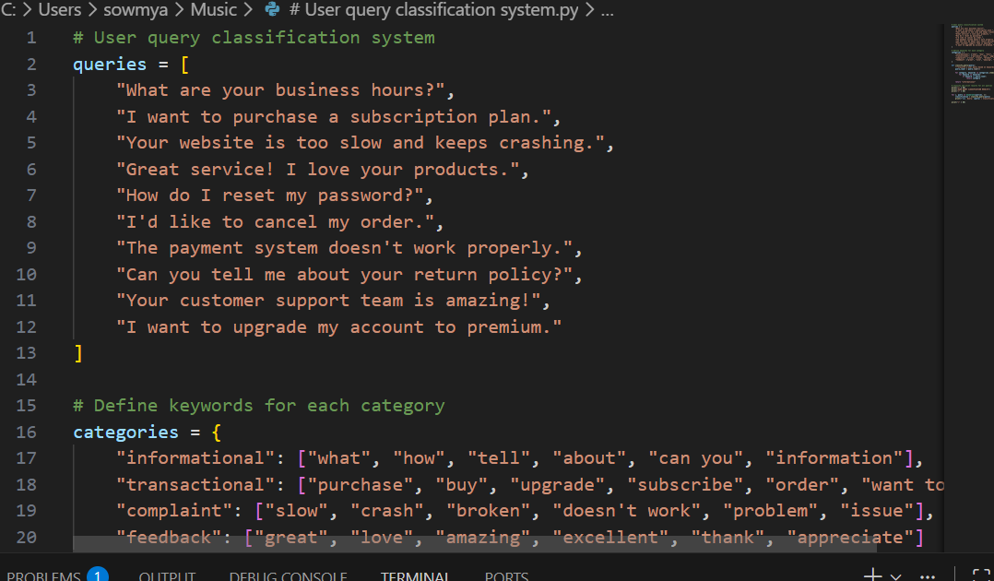
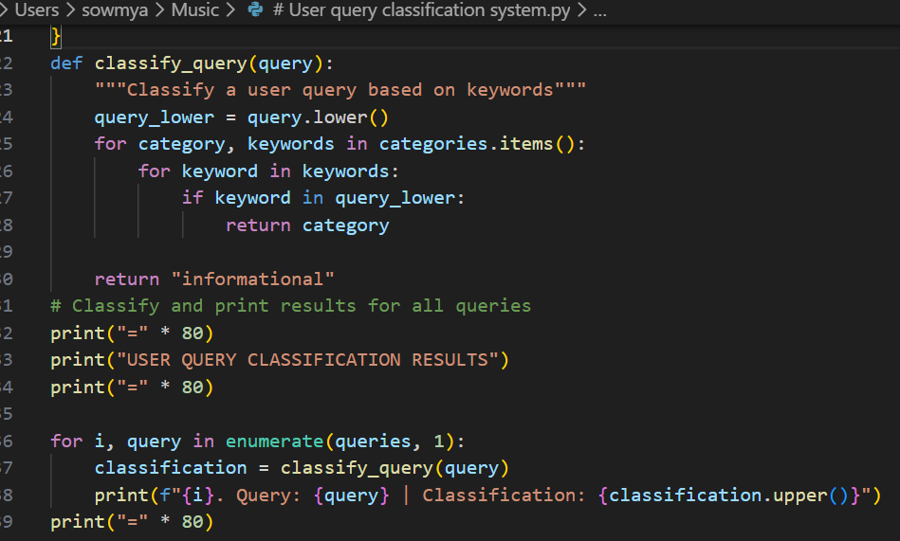
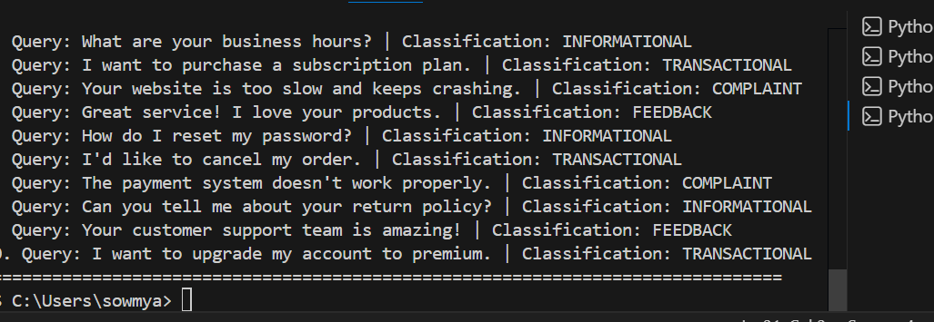
ONE SHOT:
Classify the queries mapped to classifications .Query: What are your store hours?
Classification: Informational.Now generate python code to display the output for all queries
in the same format as above. i want data in code itself not in output
